Q1. What is the difference between UI and UX? Explain in your own words.
Ans1. UI refers to the screens, buttons, toggles, icons, and other visual elements that you interact with when using a website, app, or other electronic device. UX refers to the entire interaction you have with a product, including how you feel about the interaction.

UX designers focus their work on the experience a user has with a product. The goal is to make products that are functional, accessible, and enjoyable to use. While the term UX often applies to digital products, it can also be applied to non-digital products and services (like a coffee pot or a transportation system).

UI designers create the graphical portions of mobile apps, websites, and devices—the elements that a user directly interacts with. Unlike UX, which can apply to just about any product or service, the term UI applies exclusively to digital products. A UI designer seeks to make apps and websites both visually appealing and easy to navigate.

Q2. Who is a frontend developer? Explain the roles and responsibilities in your own words.
Ans2. A front-end developer creates websites and applications using web languages such as HTML, CSS, and JavaScript that allow users to access and interact with the site or app.

Front-end developers create user interfaces (UI). UI is the graphical layout of an application that determines what each part of a site or application does and how it will look

If someone wanted to build a website, they might hire a front-end developer to create the site's layout. The front-end developer determines where to place images, what the navigation should look like, and how to present the site. Much of their work involves ensuring the appearance and layout of the site or application is easy to navigate and intuitive for the user.

Q3. Who is a backend developer? Explain the roles and responsibilities in your own words.
Ans3. Back-end developers are the experts who build and maintain the mechanisms that process data and perform actions on websites. Unlike front-end developers, who control everything you can see on a website, back-end developers are involved in data storage, security, and other server-side functions that you cannot see.

Back-end development means working on server-side software, which focuses on everything you can’t see on a website. Back-end developers ensure the website performs correctly, focusing on databases, back-end logic, application programming interface (APIs), architecture, and servers. They use code that helps browsers communicate with databases, store, understand, and delete data.

Back-end developers are required to have technical expertise, analytical thinking, and excellent collaboration skills. As a back-end web developer, you should be able to work independently to design the web infrastructure.

Q4. Create your own GitHub & Linkedin accounts. share the screenshot of both of your accounts and share your profile links of GitHub & LinTedin in the solution
Ans4. 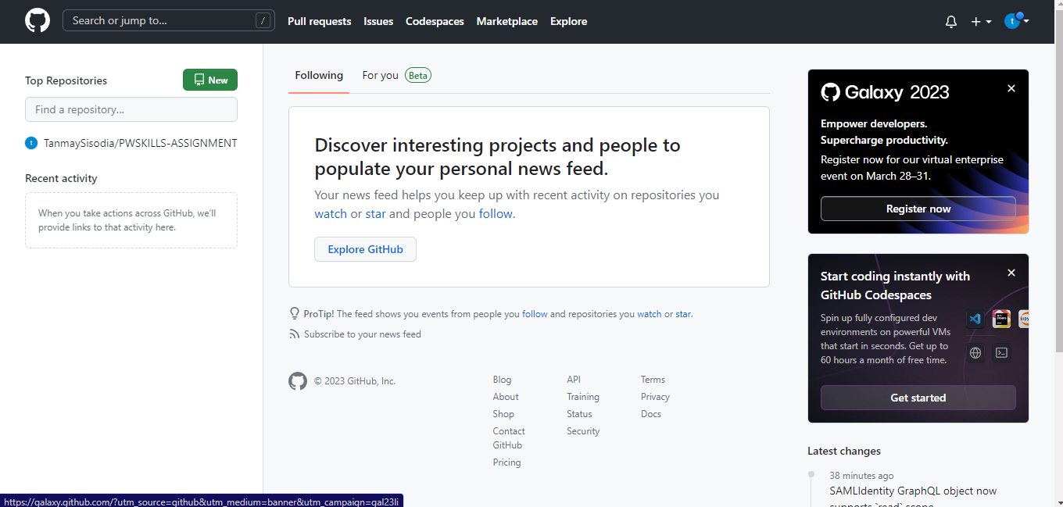
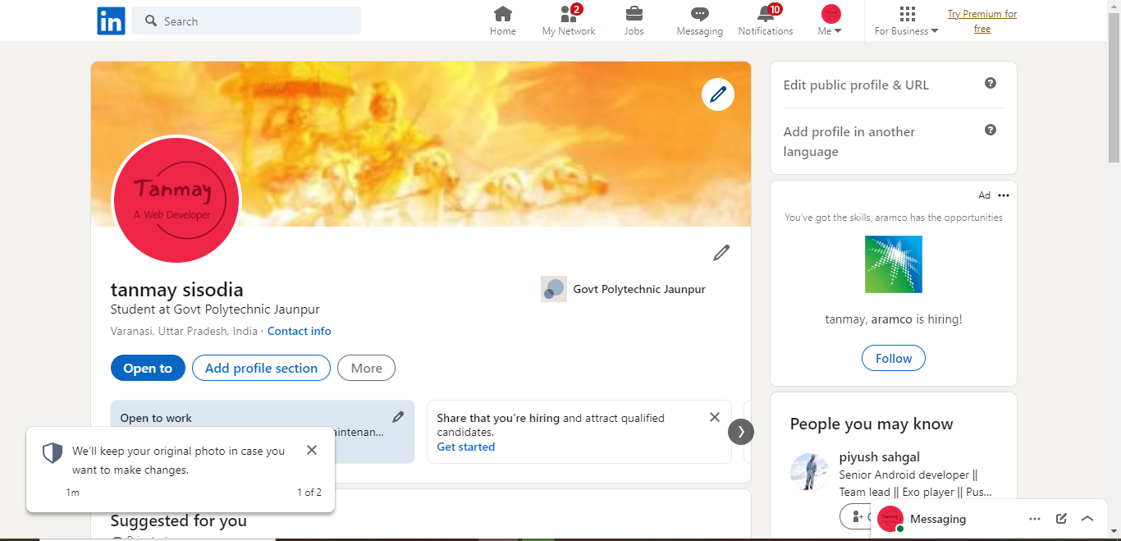
Link of github: https://github.com/TanmaySisodia.git
Link of Linkdin: https://www.linkedin.com/in/tanmay-sisodia-0b6889262/

Q5. Write your first blog on your favorite platform and share the link to the blog. (You can choose any topic for writing your 1st blog)
Ans5. I wrote a short blog on Linkdin on the rise of AI and its Advantages
Link to the Blog: https://www.linkedin.com/feed/update/urn:li:share:7047612791981023232/

